Sumama Rahim
F24BSCS039
Lab 07 Report

The total salary department wise.

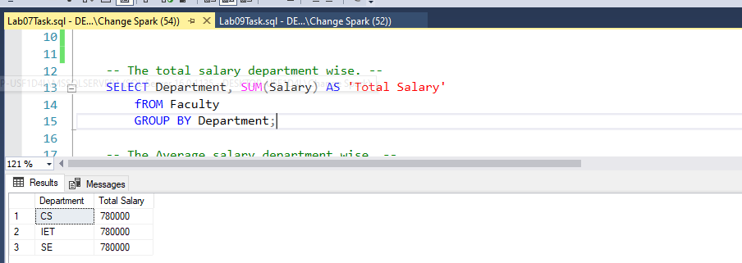
The Average salary department wise.

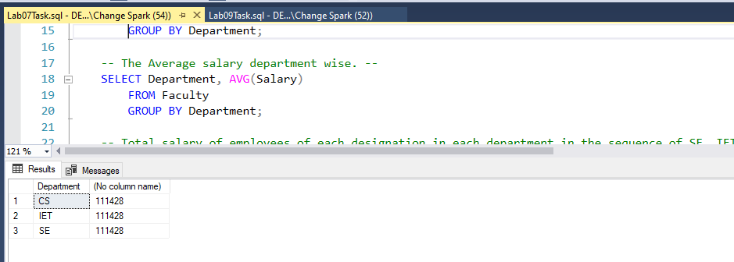

Total salary of employees of each designation in each department in the sequence of SE, IET, CS Department.
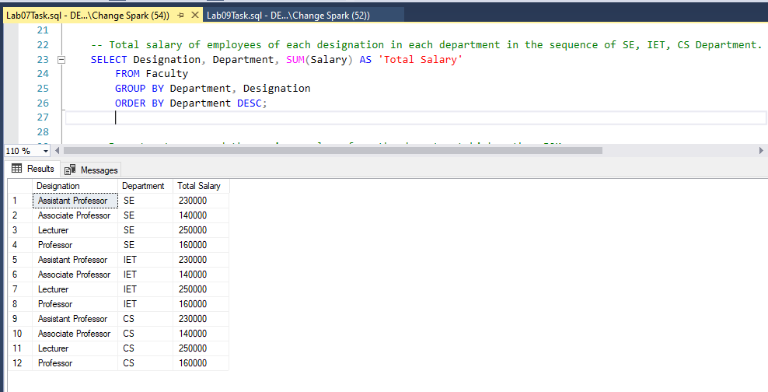

Department name and the maximum salary from the department higher than 50K.
